**Database Design  
DTEC502   
Practical Assessment – SQL Test**

Name: **Estelle Thomson**Student ID: **99246029**



1. SELECT [firstname], [lastname], [city]   
   FROM client  
   WHERE [city] = 'Dunedin';

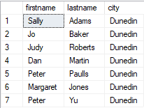

1. SELECT [firstname], [lastname]   
   FROM client  
   WHERE [lastname] LIKE 'J%';

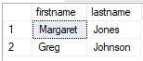

1. SELECT [firstname], [lastname], [balance]   
   FROM client  
   WHERE [balance] BETWEEN 50 AND 150;

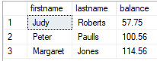

1. SELECT [firstname], [lastname], [city]   
   FROM client

WHERE [firstname] = 'Mary' AND [lastname] = 'Nelson';



1. SELECT [firstname], [lastname], [balance], [city]   
   FROM client

WHERE [balance] < 200 AND [city] = 'Dunedin';

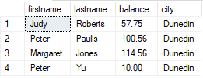

1. SELECT [custref], [creditlimit], [balance], [creditlimit] - [balance]   
   AS NewBalance   
   FROM client;

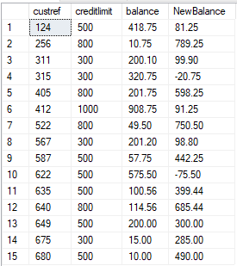

1. SELECT orderref, partref, quantity, quotedPrice, quantity * quotedPrice   
   AS LineTotal   
   FROM orderline;

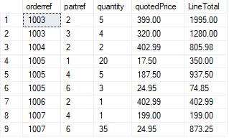

1. SELECT [orderref], [orderdate]   
   FROM [dbo].[custorder]

WHERE orderdate > '1999-06-01';

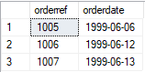

1. SELECT city, COUNT(*) AS [Number in each city]   
   FROM [dbo].[client]  
   GROUP BY city

HAVING COUNT(*) > 3;



1. SELECT rep.repref, SUM(client.balance) AS [Total balance]   
   FROM [dbo].[rep]  
   INNER JOIN client ON rep.[repref]=client.[repref]

GROUP BY rep.repref;

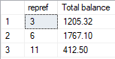

1. SELECT [city], MAX(client.balance) AS [Maximum Balance]   
   FROM [dbo].[client]

GROUP BY city;

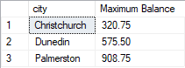

1. SELECT CONCAT(client.firstname, ' ', client.lastname) AS [Client name], CONCAT(rep.RepFirstname, ' ', rep.RepLastName) AS [Rep Name]   
   FROM [dbo].[client]  
   INNER JOIN [dbo].[rep] ON client.repref=rep.repref;

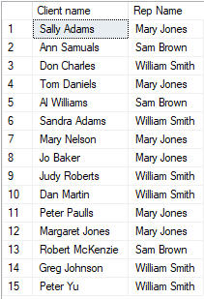

1. SELECT custorder.orderref, client.firstname, client.lastname, custorder.orderdate   
   FROM client  
   INNER JOIN custorder ON client.custref=custorder.custref;

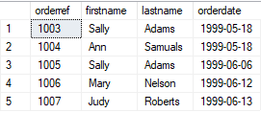

1. SELECT orderline.orderref, part.description, part.onHand   
   FROM [dbo].[part]

INNER JOIN [dbo].[orderline] ON part.partref=orderline.partref  
WHERE orderline.orderref = 1007;



1. SELECT orderline.orderref, part.description, orderline.quotedPrice, orderline.quantity   
   FROM orderline  
   INNER JOIN part ON orderline.partref=part.partref

ORDER BY part.description;

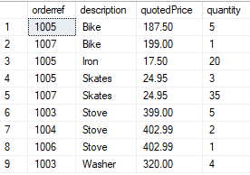

1. SELECT orderline.orderref, part.description, orderline.quotedPrice, orderline.quantity   
   FROM orderline

INNER JOIN part ON orderline.partref=part.partref  
WHERE orderline.quotedPrice > 200;

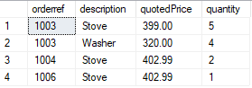

1. SELECT orderline.orderref, custorder.orderdate, client.firstname, client.lastname, part.description, part.unitPrice   
   FROM client

INNER JOIN custorder ON client.custref=custorder.custref

INNER JOIN orderline ON custorder.orderref=orderline.orderref

INNER JOIN part ON orderline.partref=part.partref;

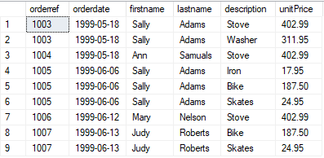

1. SELECT orderline.orderref, custorder.orderdate, client.firstname, client.lastname, part.description, part.unitPrice   
   FROM client

INNER JOIN custorder ON client.custref=custorder.custref

INNER JOIN orderline ON custorder.orderref=orderline.orderref

INNER JOIN part ON orderline.partref=part.partref

WHERE custorder.orderdate > '1999-06-10';

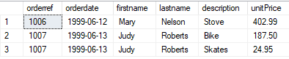

1. SELECT orderline.orderref, custorder.orderdate, client.firstname, client.lastname, rep.RepFirstname, rep.RepLastName, part.description   
   FROM client

INNER JOIN rep ON client.repref=rep.repref

INNER JOIN custorder ON client.custref=custorder.custref

INNER JOIN orderline ON custorder.orderref=orderline.orderref

INNER JOIN part ON orderline.partref=part.partref;

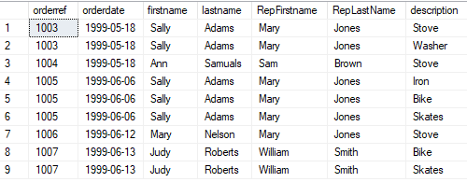

1. SELECT CONCAT(rep.RepFirstname, ' ', rep.RepLastName) AS [Rep Name], SUM(client.balance) AS [Total balance] FROM [dbo].[rep]

INNER JOIN client ON rep.repref=client.repref

GROUP BY rep.RepFirstname, rep.RepLastName;

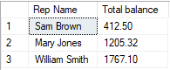

1. SELECT orderref, SUM(quantity * quotedPrice) AS [Total Linetotal]   
   FROM orderline

GROUP BY orderref;

